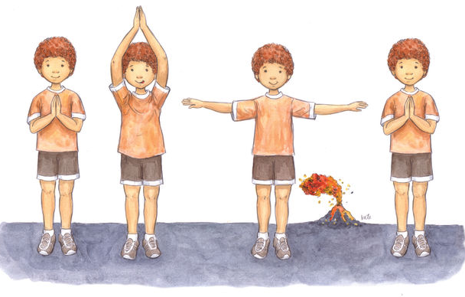
Volcano Breath source: https://www.newsoulcollection.com/blogs/yoga/12-illustrations-to-teach-kids-yoga-poses

